EXPERIMENT 3:
1: 1.Select employees with salaries greater than 7000.
QUERY
1:CREATE TABLE Employee__55__ (Emp_id int PRIMARY KEY,EMp_name varchar(30),Dept varchar(30),Salary int);
INSERT INTO Employee__55__(Emp_id,EMp_name,Dept,Salary)values(101,'Amala','HR',5000);
INSERT INTO Employee__55__(Emp_id,EMp_name,Dept,Salary)values(102,'DAVID SMITH','MARKETING',8000);
INSERT INTO Employee__55__(Emp_id,EMp_name,Dept,Salary)values(103,'CATHY','PRODUCTION',3000);
INSERT INTO Employee__55_(Emp_id,EMp_name,Dept,Salary)values(10,'OLIVER','PRODUCTION',6000);
SELECT *
FROM employee__55__ WHERE salary > 7000;
2: Update the salary of 'David Smith' to 8200.00.
UPDATE Employee__55__ SET Salary=8200 where Emp_id=102;
SELECT * FROM Employee__55__;
3: Insert a new employee with Emp_id = 6, Emp_name = 'Daniel Harris', Dept = 'Production', and Salary = 6700.00.
4: Delete the employee with Emp_id = 3 ('Charles Brown').

OUTPUT:1

output2:
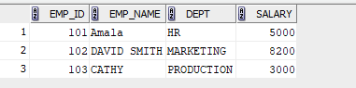

output3:
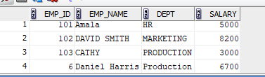
Output4:
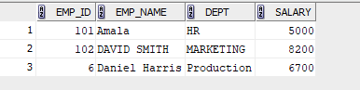
5: . Select employees whose names do not start with 'D' or 'O.'

6: SELECT Dept,SUM (Salary) from Employee__55__ group by Dept;

7: .Update the salary of employees in the 'Production' department by adding 5% to their current salaries.
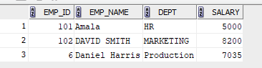
8: Delete all employees with salaries below 7000.

